**Practical Lab 4**

**Student ID: ____________________ Student Name: _________________________**

**Q1.** Test the following php codes:

1. Create an empty txt file named: test.txt, set the permission as 777
2. Copy and paste the below code to create a php file, such as b.php, permission as 755
3. Go to titan.csit.rmit.edu.au/~sXXXXXXX/b.php

**b.php**

**<html>**

**<body>**

**We assume there is a table in the database, named text.txt**

**<br/><br/>**

**<?php**

**//open a file named "text.txt"**

**$file = fopen("test.txt","w"); //"w"=overwrite**

**$anything = "hello world!";**

**//write into the users.txt file**

**fwrite($file,$anything);**

**//close the "$file"**

**fclose($file);**

**?>**

**Done! Check the test.txt file.**

**</body>**

**</html>**

Think about fopen(), fwrite() and fclose() functions.

**Q2.** Based on **Q1**, append data into the file without overwriting existing data and append the new data in a new line.

Hint: [https://www.w3schools.com/php/func_filesystem_fopen.asp](https://www.w3schools.com/php/func_filesystem_fopen.asp%20)

"w"=overwrite, “?”=append

**Q3.** Write a clinet.html, server.php and database.txt to take something from client side and store it into database.txt.

**Step 1**. Access to your titan server, and create 3 files under your student folder: **database.txt** (permission 777), **server.php** (permission 755) and **client.html** (permission 755)

How to change permission: right click the file, click Properties, enter 755 or 777 in Octal, click OK.

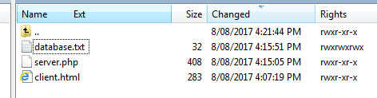

And keep the database.txt as empty. To check the content of database.txt, please right click the file and click Edit

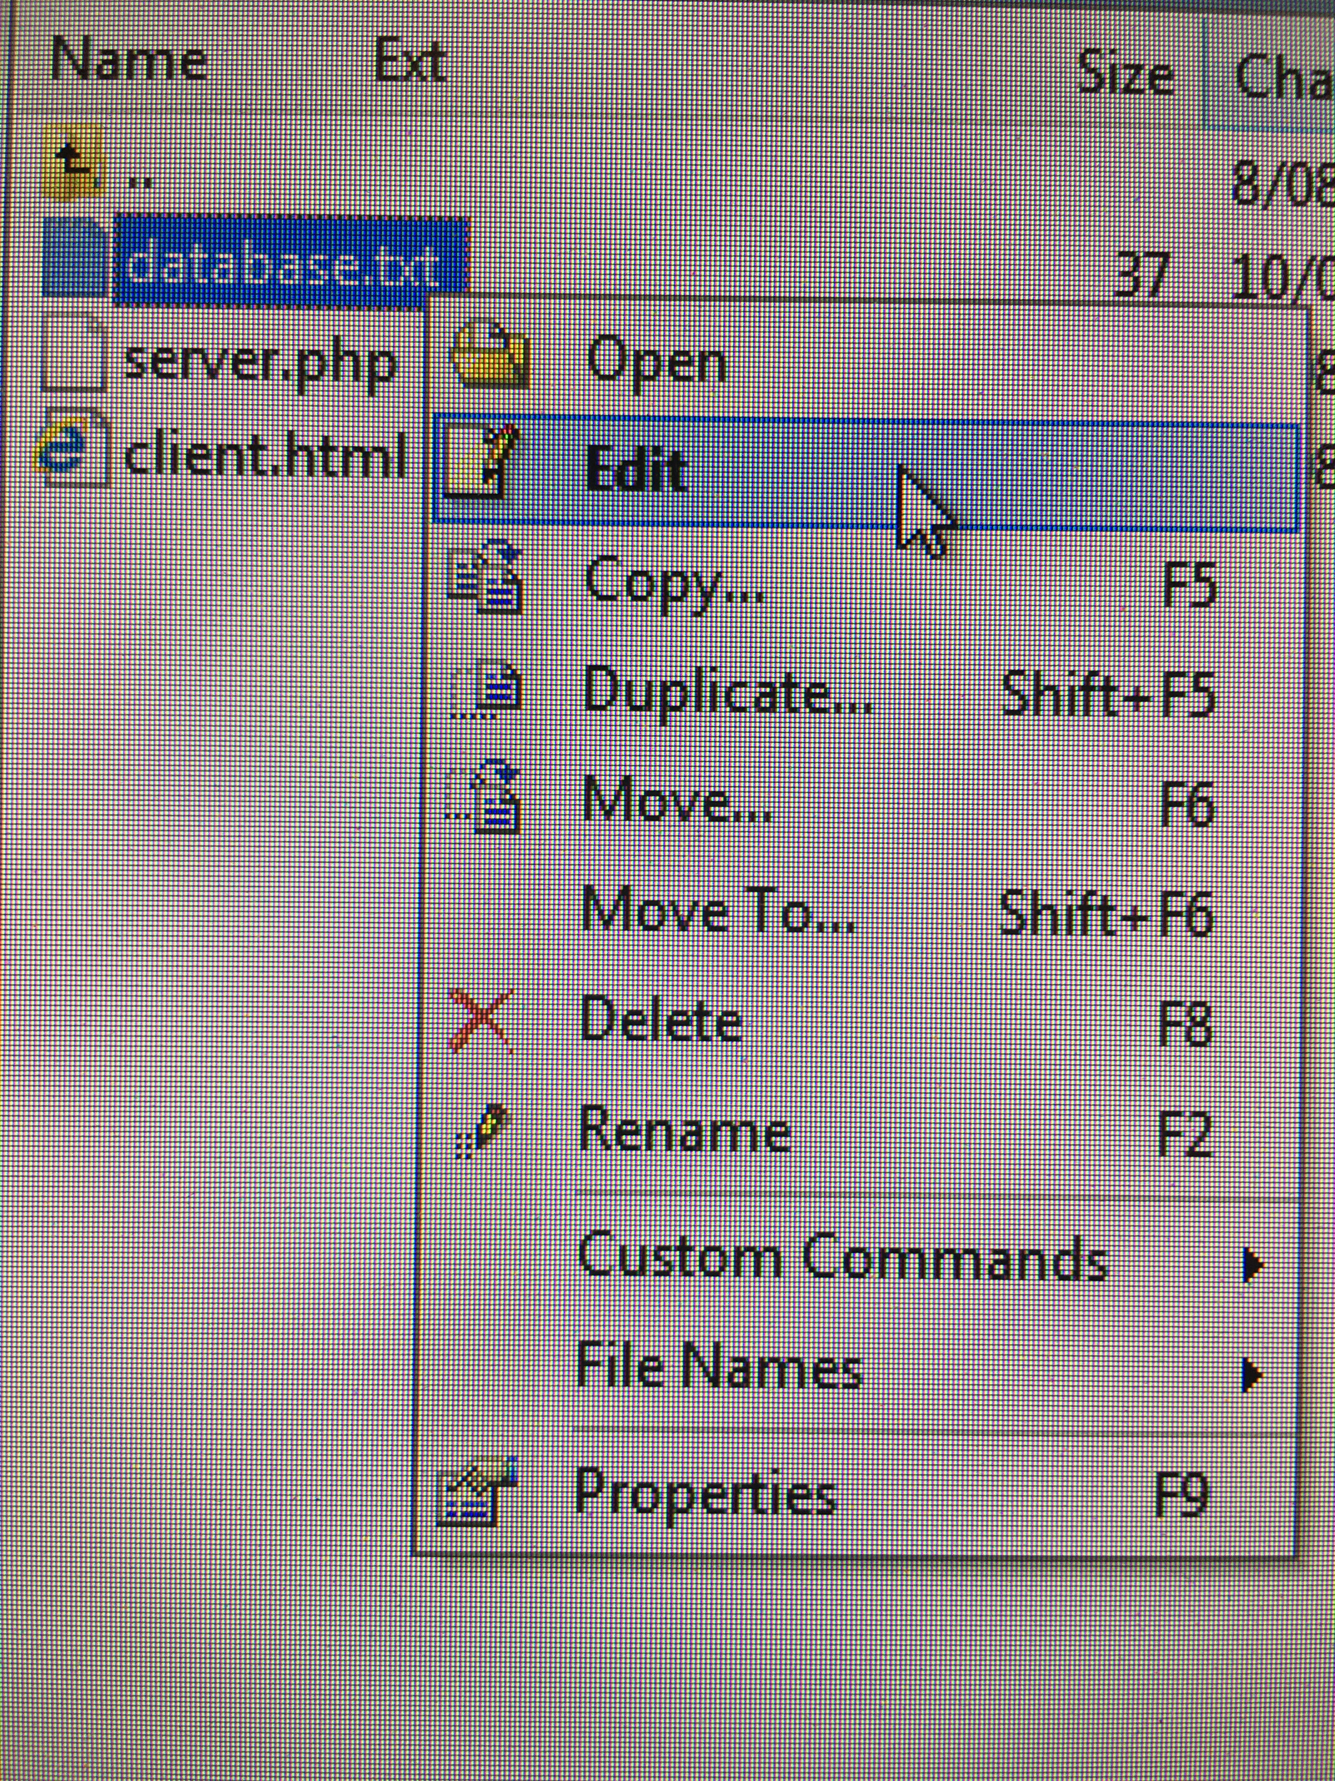 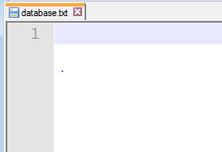

**Step 2.** Write clinet.html (refer to previous Labs) as below

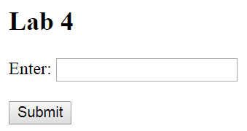

**Step 3.** Write server.php based on **Q1** to

3.1 receive the user’s input from client.html

3.2 open database.txt

3.3 write user’s input into the database.txt

3.4 close database.txt

**Step 4.** Go to your own web link, such as **titan.csit.rmit.edu.au/~sXXXXXXX/client.html**

**Expected outcome of Q3:** every time you submit anything, the content will be added into the database.txt with a new line.

To check the content of database.txt, please right click the file and click Edit



**First time:**

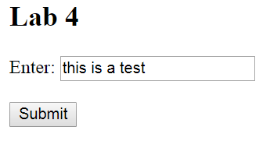 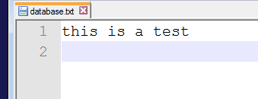

**Second time:**

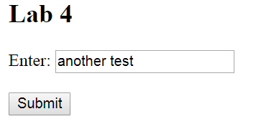 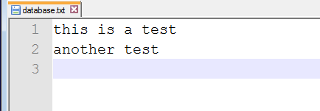

**Third time:**

